Creating an Object Identifier (OID) at the MDCH OID Registry
These instructions describe the process for requesting and receiving an Object Identifier (OID) from the Michigan Department of Community Health OID Registry and—for parent organizations with sub-facilities—assigning OIDs for sub-organizations. The document was created to support users of Michigan public health systems that require OIDs as identifiers.

OID Use in Michigan Public Health Systems

The Michigan Birth Defects Registry (MBDR), Michigan Cancer Surveillance Program (MCSP), and the Michigan Syndromic Surveillance System (MSSS) require the use of OIDs in the HL7 (MSSS) and HL7 CDA (MBDR and MCSP) messages. There are two OID levels required—the organizational OID and the facility OID, also referred to as the “root OID” and “sub-organization OID,” respectively. The Organizational OID represents the sender of the message. The Facility OID corresponds to the facility location where the patient was treated. For example, if a patient is seen at Lansing Central Hospital, which is part of the Lansing Hospital System, and has a unified EHR, there would be an Organizational OID for the Lansing Hospital System and a facility OID for Lansing Central Hospital. For single-facility practices where the location of patient treatment is also the sender of the message, the facility/sub-organizational OID may be the same as the Organizational/root OID.

MDCH has created an OID Registry to generate and store Organizational OIDs for providers interested in participating with the MBDR, MCSP, or MSSS. Below are instructions on how to use the Web site to generate an OID for your organization.

Introduction to the MDCH OID Registry
The MDCH OID Registry is available at https://mimu.michiganhealthit.org/OID/.

The links along the top allow you to navigate through the screens:
- Click MDCH OID Registry or Home to return to the welcome page, where you can choose to register for an OID or log in to view the OIDs you already created.
- Click OIDs to view or edit OIDs you already created. You must be logged in to see your OIDs.
- Click Contact for the email address where questions can be sent (dchpublichealthmu@michigan.gov).
- Click Log off to exit the MDC OID Registry.

Creating a New OID
- Go to https://mimu.michiganhealthit.org/OID/ to begin. The MDCH OID Registry appears.
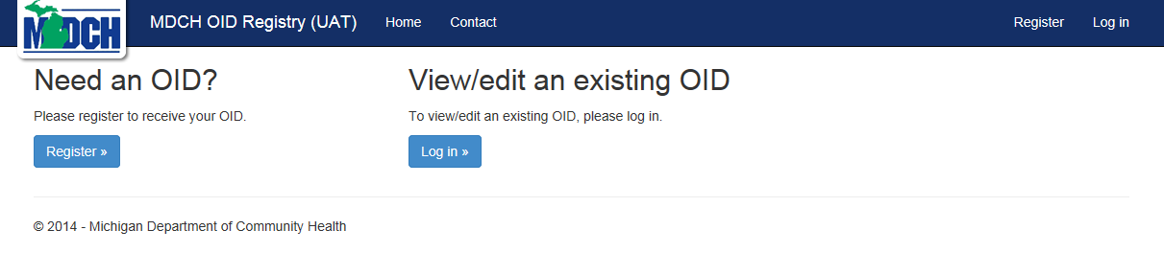
- If this is your first time at the MDCH OID Registry, click Register. If you have already registered, click Log in and skip to Step 9.
- Once you click Register, you’ll be prompted to create a new account.
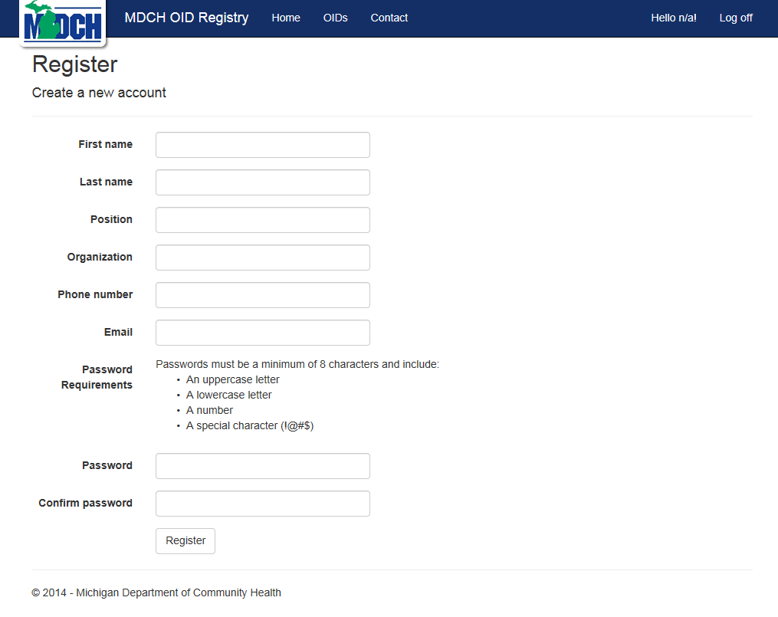

- Complete the new account fields and create an account password.
  - Passwords must be at least eight characters long and have at least one special character, one lowercase letter, one uppercase letter, and a number.
  - Note: Your account login will be your email address, so be sure to enter one here.
- When the new account information is complete, click Register.
- You will be prompted to confirm your account.
- Go to the email account you specified when creating your account. You should receive an e-mail message from sender noreply@mphi.org. Open the message and follow the instructions.
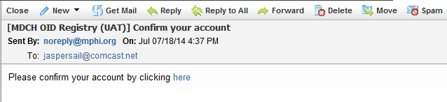
- When prompted that your account is confirmed, click the link to log in.
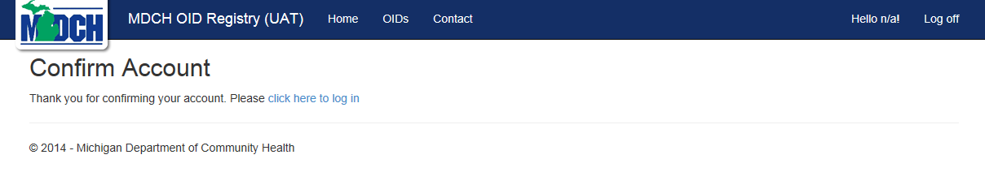
- Enter your login credentials and click Log in.
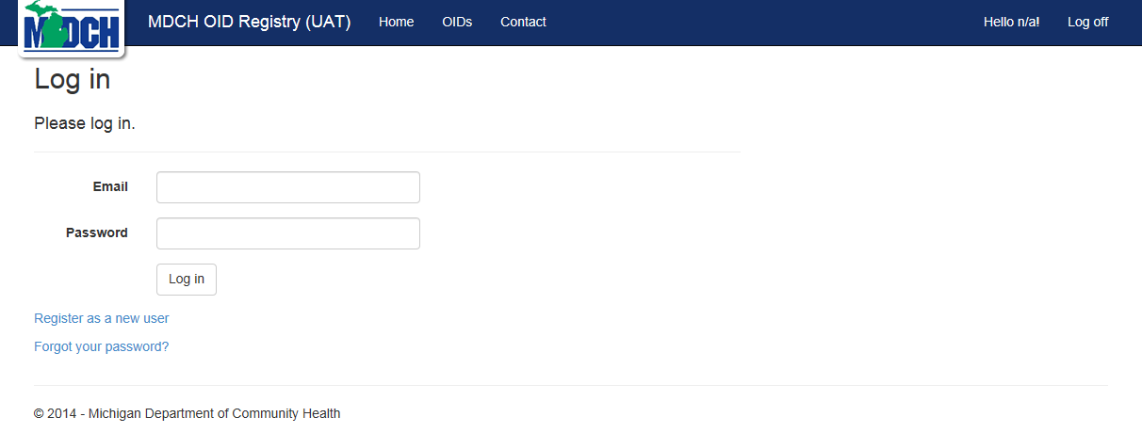
- Once logged in, the Create OID page appears. Enter contact information for the OID point of contact (POC).
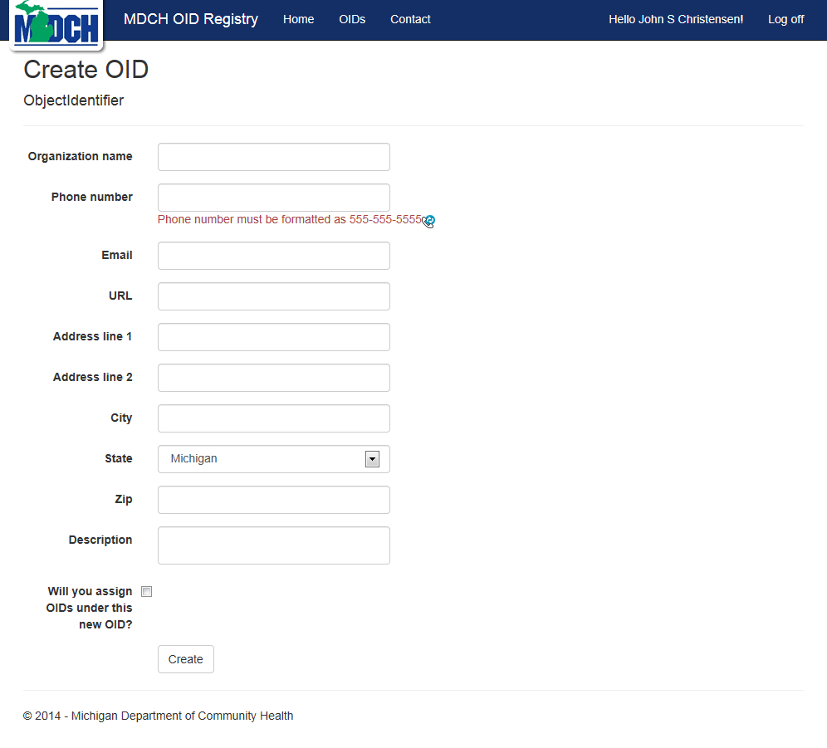
  - Organization name—What organization (e.g., health system) will this “root” OID represent?
  - Phone number—Enter the POC phone number in xxx-xxx-xxxx format.
  - Email—Enter the email address of the POC for this OID.
  - URL—Does the organization have a Web site? If so, enter it here.
  - Address line 1—Enter the organization’s address.
  - Address line 2—Enter the organization’s address (if additional space is required).
  - City—Enter the city of the organization.
  - State—Select the state in the drop-down list.
  - Zip—Enter the organization’s zip code.
  - Description—Enter a brief description of the organization that will “own” this OID.
  - Will you assign OIDs under this new OID?
    - Select the checkbox—If your organization has multiple facilities that will need sub-OIDs, select the checkbox. Checking the box enables you to define branch OIDs in your organizational tree. You may want to choose this option even if you are a single-facility organization but want the ability to assign sub-OIDs if your organization grows in the future.
    - Don’t select the checkbox—If your organization is just a single facility and will likely never grow to add facilities, you can leave the checkbox unchecked. This limits your organization to one single OID that functions as your organizational and facility OID, which may be all that you need.
- When you’ve completed the information, click Create.
- The system will display your assigned OID on the screen with your organization name, your sub-OID assignment selection, and the date it was created.
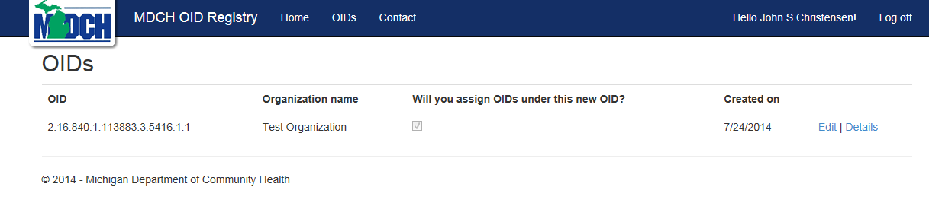
- From this screen you can also choose to review details of your OID or edit the POC data.
  - Click Edit to change any of the POC entries made when setting up the OID.
  - Click Details to review the POC details for this OID.
  - You can always click OIDs at the top of the screen to return to this window.

Assigning OIDs for your Sub-organizations
If you are submitting public health data to Michigan from multiple sites (i.e., event or service locations), each site will need its own facility OID number, which will be an extension or branch off your organization’s root OID (e.g., 888.888.8.88) plus some numbering scheme you define (e.g., 888.888.8.88.1, 888.888.8.88.2, 888.888.8.88.3).

Since no other organization shares your root OID, you simply need to make sure the numbers you add create a unique OID for each sub-organization within your root.

The assignments and branching numbers you use are up to you, but please do not use leading zeros (e.g., .01, .002, .003) as they may not process properly in public health systems. Instead, please ensure that your branches start with a number between 1 and 9. For example:
- Correct: 9.99.999.9. 999999.9.9999.1000
- Incorrect: 9.99.999.9. 999999.9.9999.0001
Please keep track of your branch OID assignments—you will need to define and use them when onboarding with some of Michigan’s public health systems.

